KSPI -

Functionality
Plan price calculation determines prices for the plan activity types of each cost center and activity type.

Activity types will be applied to allocate planned employees cost (total payroll of R&T/STC) to research projects/orders based on the productive and non productive research hour rate worked for each project.
Scenario
In this transaction plan activity prices are calculated.

Requirements
Planned cost splitting has been executed successfully.

Menu Path | Accounting → Controlling → Planning → Allocations → KSPI - Price Calculation
Transaction Code | KSPI

1. Double Click on KSPI - Price Calculation

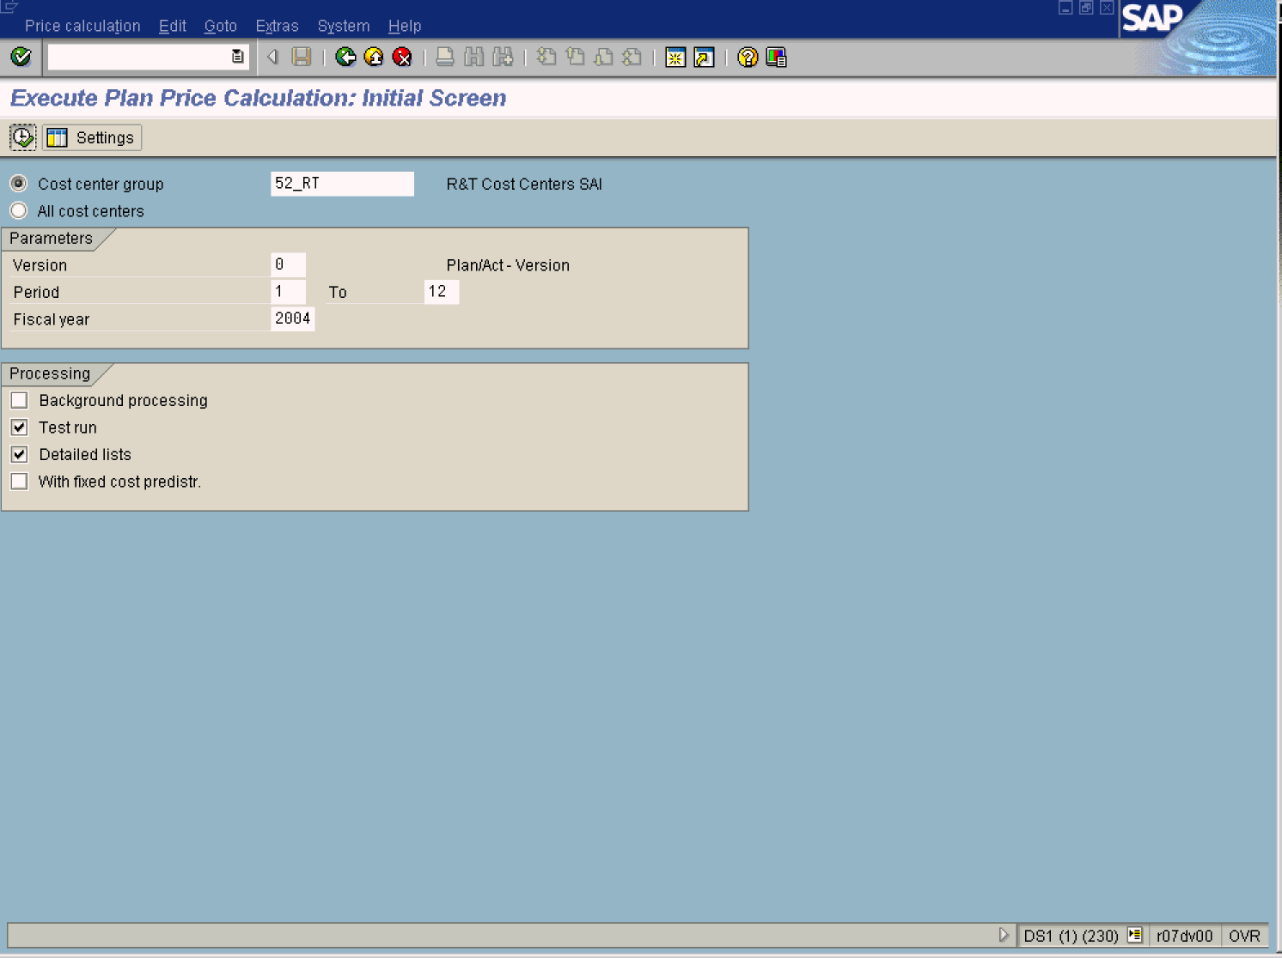
2. Update the following fields:

Field Name | Description | Values
Cost center group | Code identifying a grouping, for internal reporting purposes, of cost centers with similar characteristics | Example: 52_rt
Version | Controlling area related collection of year-dependent indicators for planning data. | Example: 0
From Period | Number identifying a fiscal month. | Example: 1
To Period | Number identifying a fiscal month. | Example: 12
Fiscal Year | Enter the fiscal year. | Example: 2004
3. Deactivate the test run indicator.
4. Press Enter to confirm your entries.
5. Click Execute .

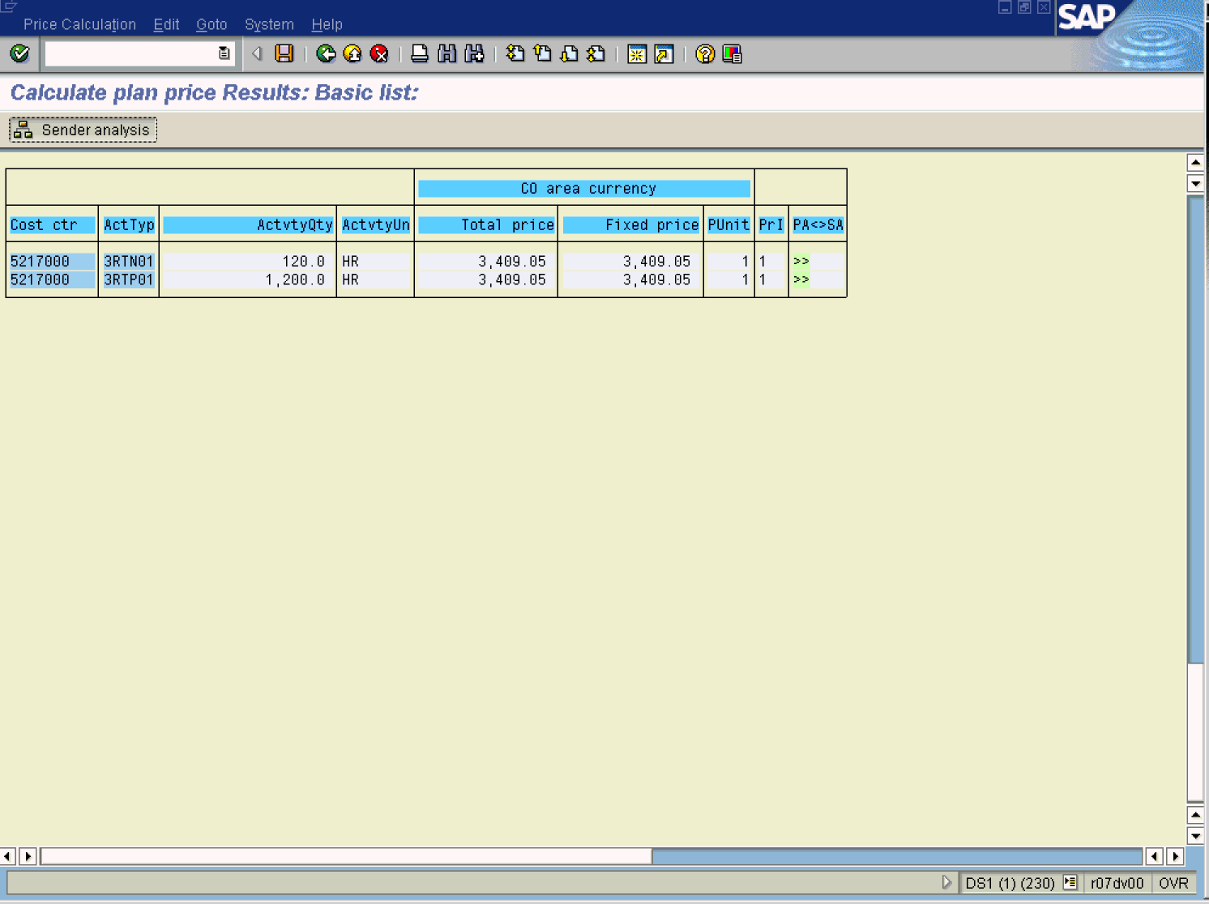

6. Click 5217000 Button .
7. Click Sender analysis Button .

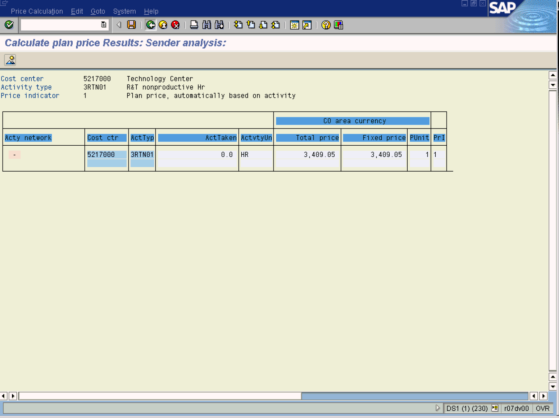

8. Click Back .

Calculate plan price Results: Basic list:

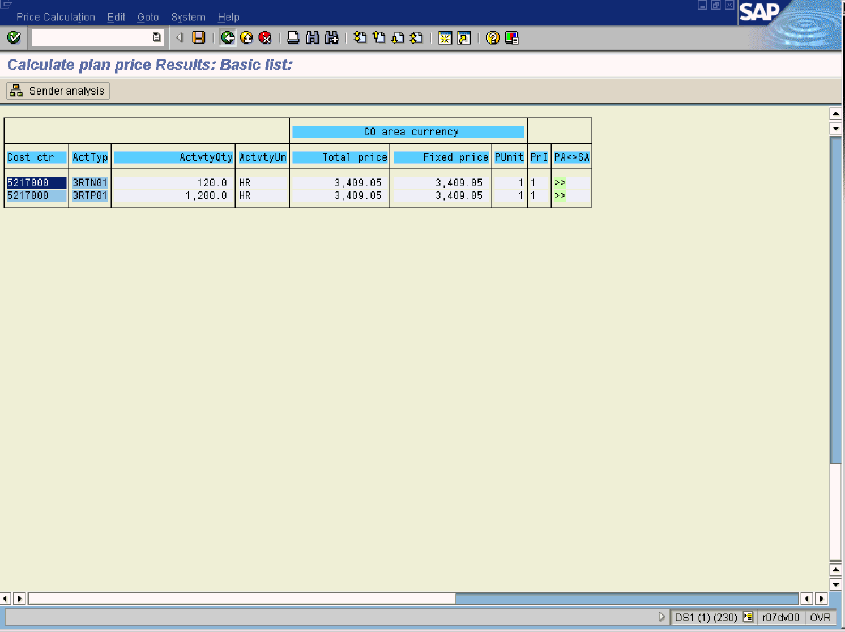
9. Click Back .

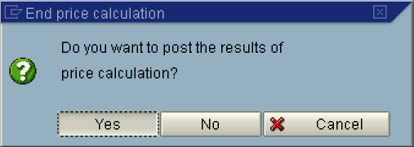

10. Click the Yes Button.

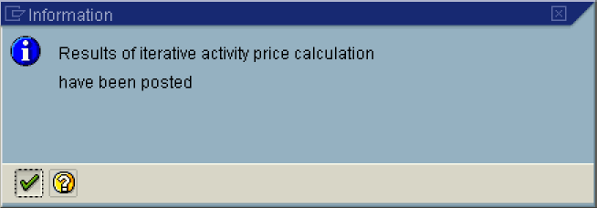

11. The message bar displays “Results of iterative price calculation have been posted.”

